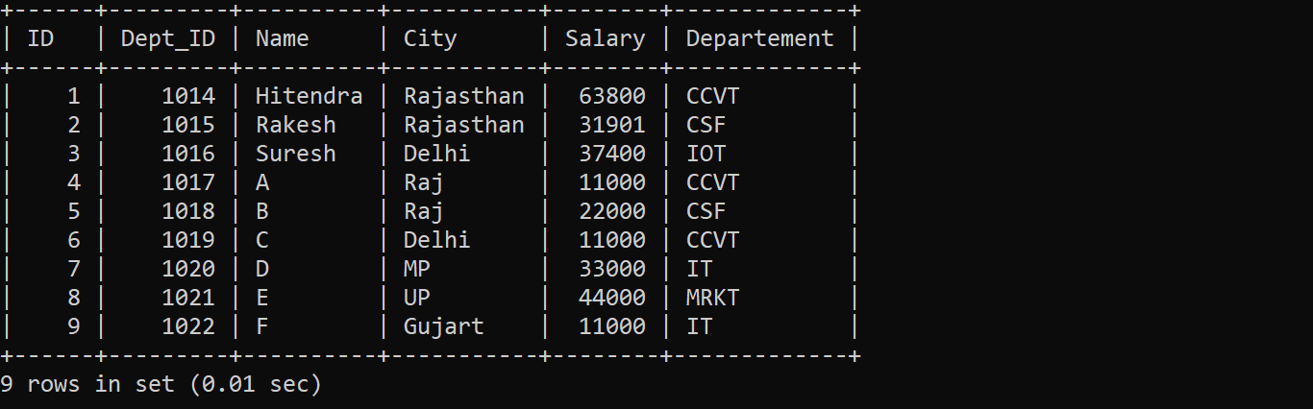

**1) Alter ()**

**a) Add column**



**b) Add multiple column**



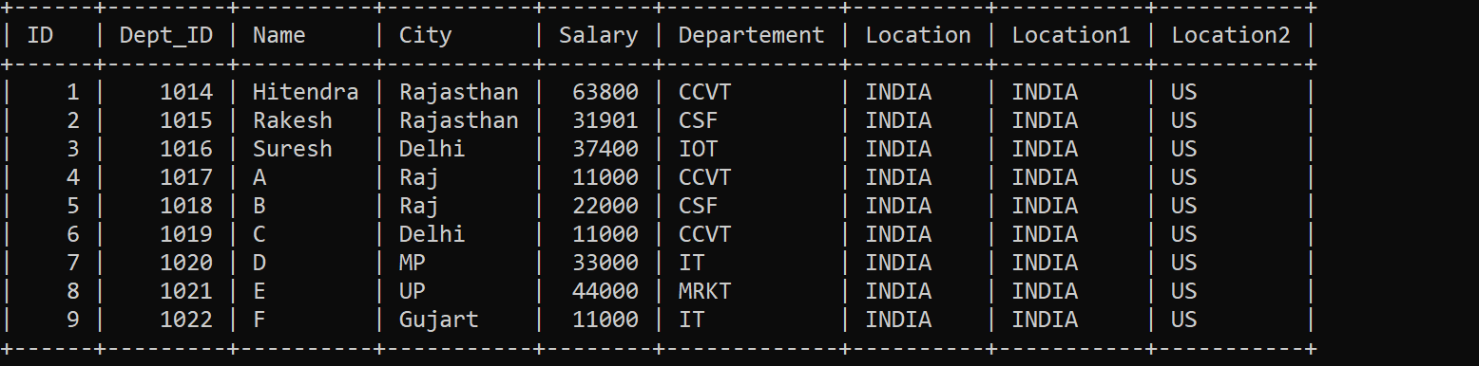

**c) remove column**



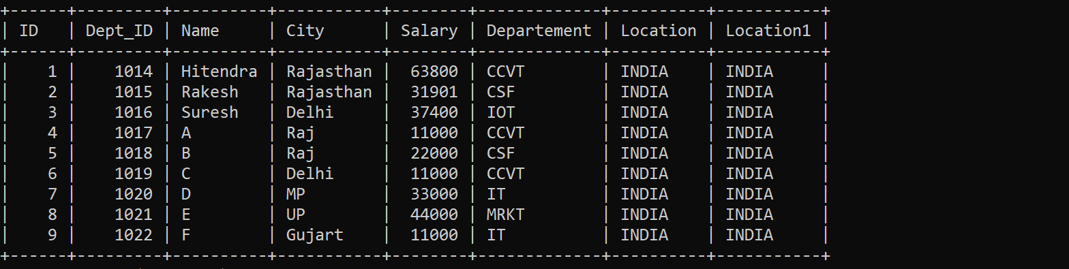

**d) remove multiple column**



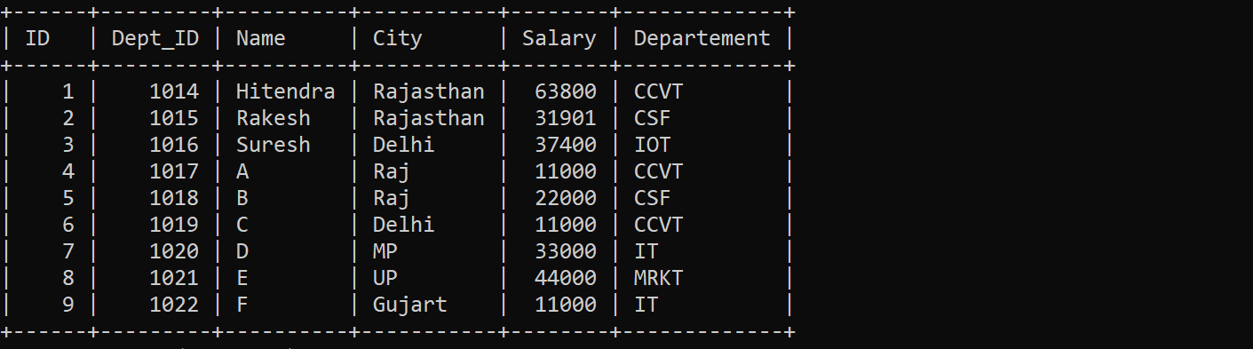

**e) Modify datatype**



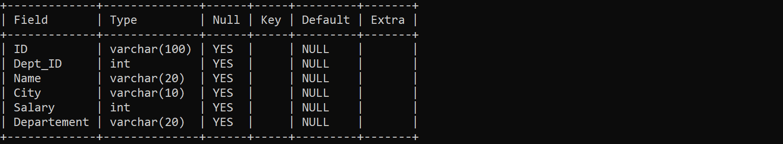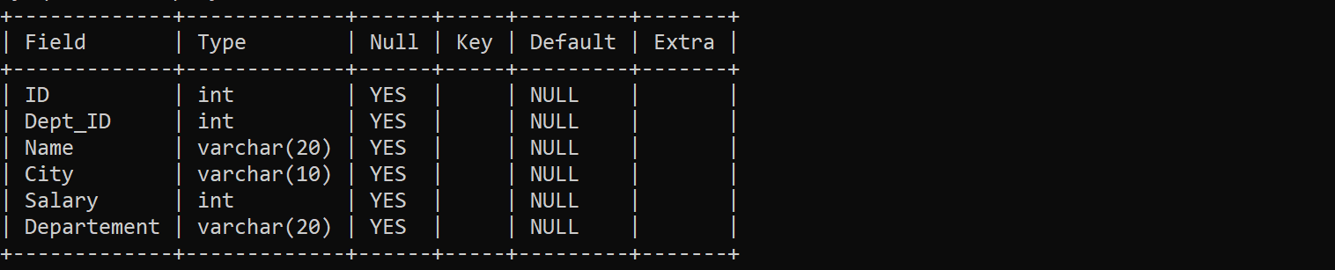

**f) Modify Multiple datatypes**



**G) Modify Multiple col’s datatype length**



**Add constraints -------------🡪 Primary Key**

**ALTER TABLE table_name**

**ADD CONSTRAINT MyPrimaryKey PRIMARY KEY (column1, column2...);**



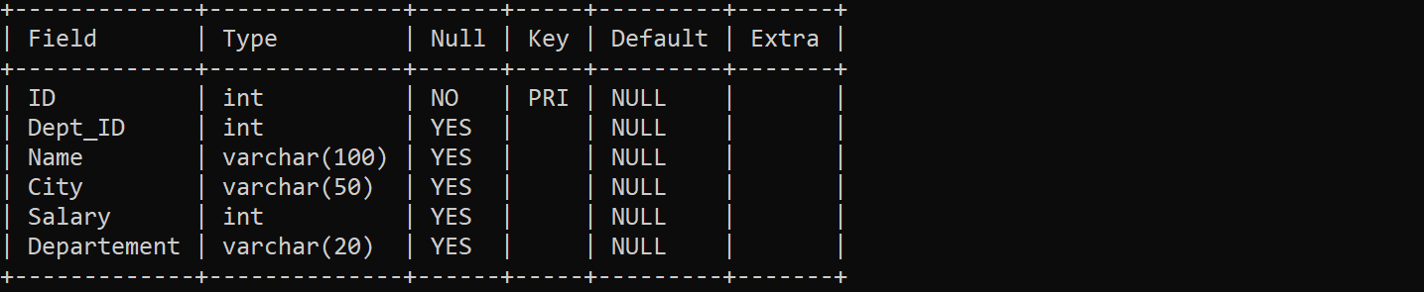

**Add Constraint -----------🡪 Check Constraint**

**ALTER TABLE table_name**

**ADD CONSTRAINT MyUniqueConstraint CHECK (CONDITION);**



**Add Constraint -----------🡪 Unique Constraint**

**ALTER TABLE table_name**

**ADD CONSTRAINT MyUniqueConstraint UNIQUE(column1, column2...);**



**Add Constraint ---------🡪 Not NULL constraint**

**ALTER TABLE table_name MODIFY column_name datatype NOT NULL;**



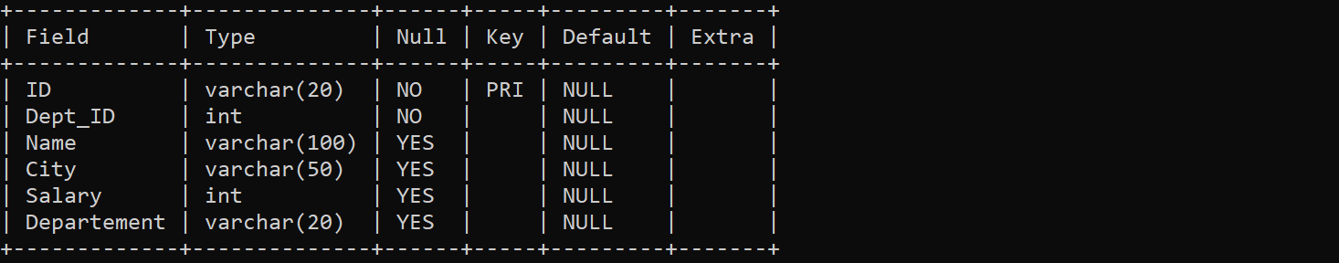

**Add Constraint ----------🡪 Default constraint**



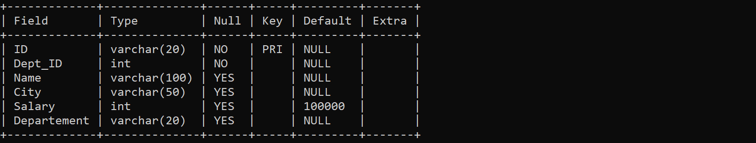

**Add Constraint ----------🡪 Foregin Key**

ALTER TABLE Orders  
ADD CONSTRAINT FK_PersonOrder  
FOREIGN KEY (PersonID) REFERENCES Persons(PersonID);

**Drop Constraint -----------🡪 Primary Key**



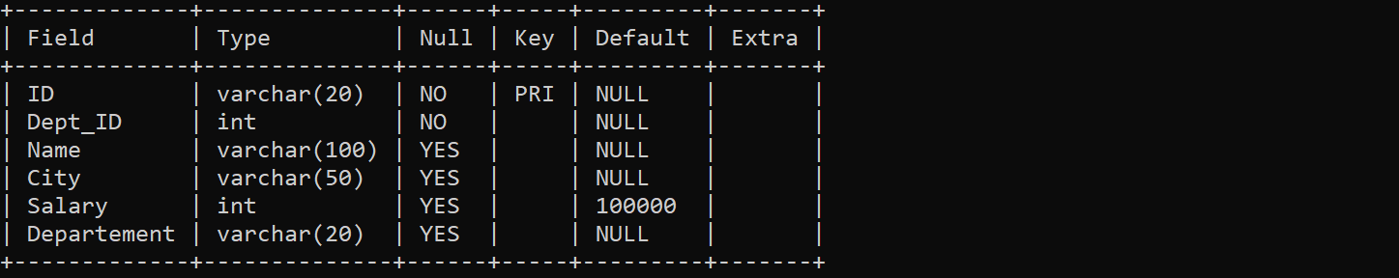

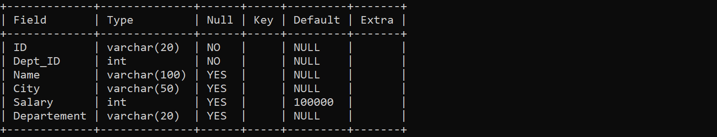

**Drop Constraint -------🡪 check**



**Drop Constraint ------🡪 Not NULL, Default**



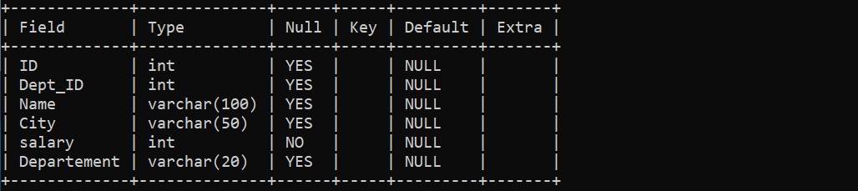

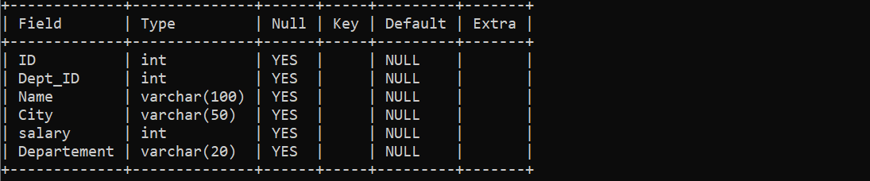

**Rename columns**



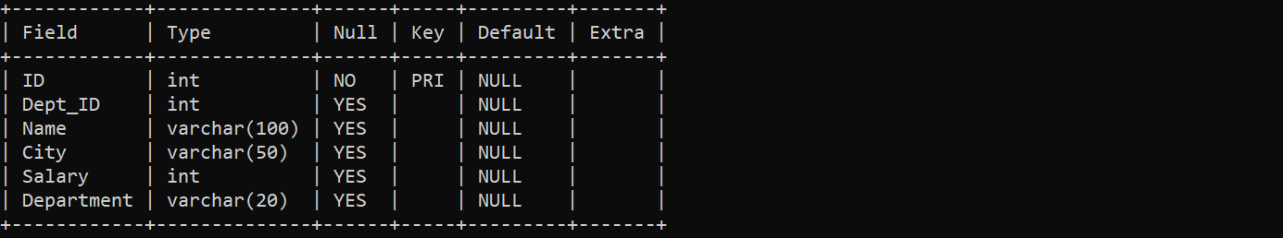

**Rename table name**

